Prioritize

Joel Wilhelm, Cody Jones, Wajahat Iqbal, Shahrukh Rehman

# Project Goal

Reminder System that incorporates a priority value with time.

# Project Description

Prioritize is an application that aims to organize the user’s life by letting them type in a reminder for something that needs to be done by a certain time, and reminding them in intervals based on priority and the time between creation and the “due-date.” This lets the user periodically be reminded of the event or task over time rather than the user deciding having to decide for themselves. Once reminded, the user can choose to have the reminder be stopped, snoozed to remind the user in an hour or so, or simply be reminded at a later time that is again based on the priority value and the time between the current date and the “due-date.” These reminders will be synced across the user’s android devices allowing them to be reminded at any convenience to them.

# Requirement Specifications

## Functional Requirements:

The user must be able to create a new reminder. When creating a reminder, the user must be able pick a date and have the option of picking a time with that date. The user must also be allowed to pick multiple dates. The user must be able to view the current list of reminders that have been created and have the option of deleting them and editing them. The option of picking a alert versus an alarm must be available, that is a simple notification versus an alarm that won’t go off until user interaction. A reminder must have the option of being repeated. When a reminder is being alerted the notification itself must have the option of “Snooze” which tells the app to remind the user again sooner than later, “Remind me Later” which sets another reminder based on percentage of time remaining via the priority algorithm, and “Stop Reminding Me,” this will cancel the reminder entirely and leave it on the reminder list until the date/time has passed.

## User Interface Requirements:

The UI must implement a minimalistic design. The home page must display a list of the current reminders along with a floating action button at the bottom right for adding a reminder. Swiping to the right must reveal a calendar that has a mark on the dates that have each reminder due date, along with a mark for when that reminder is being alerted. The two of these marks must be displayed in a different style for differentiation.

## Usability Requirements:

The user must be able to create a reminder in a substantially small amount of time. These reminders must be synced automatically with the rest of the users android devices that have the application installed on them under the same Google Account.

## Performance Requirements:

The application must have a minimal response time in order for creating a reminder swiftly, and uninterruptedly. That means punctual app transitions, 0.1 seconds, opting for quick GUI animations rather than slower ones. Syncing across android devices must be as quick as the Google Drive API allows.

## Security Requirements:

The users reminders must not be available for viewing by anyone other than the user and then only through the application itself. The Google Drive API used to syncing android devices uses Google’s account system for security in the cloud.

# System

When user creates a reminder a description is set by the user, a date (or dates) is set by the user, a time is optionally set by the user, a priority value is set via a slider, and the user has options for ignoring the priority system, setting it to be repeatable, and changing from the default alert style to an alarm style notification. Once the reminder is submitted, the priority algorithm takes the priority value, the current date and time, and the date (or date and time) of the reminder and calculates a date and time for the user to be reminded based on the percentage of time between the two dates. The information the user entered and the new priority date is saved in a local device database and is synced with the user’s Google Cloud via the Google Drive API. This allows for the user’s other android devices that have the application installed under the same account to sync with the Cloud and set the reminder on that system as well. The alerts are set via the Android system which lets the application be closed until the time of activation of the event.

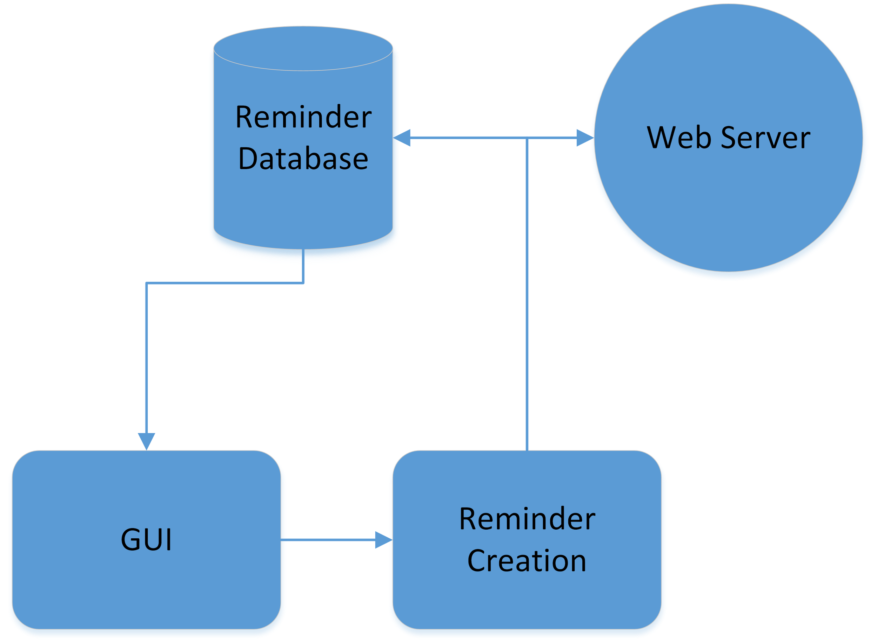

Fig. 1

# Subsytems

* Home Activity: Fragment system for activity to display the current list of reminders on one slide, while swiping right reveals a calendar with reminders marked on dates.
* Notifications: Reminds the user of the task depending on the priority set by the user through sending a notification via an alert or an alarm. Notifications will offer Snooze, Remind Me Later, and Stop Reminding Me.
* Reminder Database: Manages the user’s reminders, this database is synced with the cloud so that the user’s other android devices can share all of the same information.
* Priority Algorithm: Set’s the date and time for the user to be alerted about a task they have created a reminder for. Takes the time between the date of creation and the “due-date” to set a new date based on the percentage of time between the two.
* GUI: Provides the user with menu, buttons, and calendar for priority, date and time input.
* Adding a Reminder: System for the user to create a reminder to be added to the reminder database. Has field for reminder description, date picker, time picker, repeatable check, alert/alarm switch, and the option for ignoring priority system.

# 

Fig. 2 Fig 3.

# Timeline

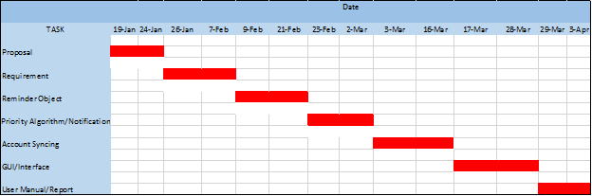

Fig. 4.

Risk Factors

There are many risk factors involved in any project undertaking. So, it is therefore natural that there are risk factors within Prioritize as well. Listed here are potential risks factors that may have an impact on the success and implementation of Prioritize.

* Time – Time is always a factor in any project, big or small. If not enough time is available, the project may become rushed, and will suffer thusly. There is limited time in which to plan, prepare, and implement Prioritize. Thusly, time is a risk factor.
* Experience – None of the team has used Android Studio before, or programmed an application designed for a mobile device. This lack of experience is a risk factor, because time investment is mandatory to learn about the environment, and to understand what is necessary to begin implementation.
* Groupwork – The fact is that Groupwork can be difficult. Lack of communication is a major factor in failed projects, so being able to communicate is vital. The fact that group members have other classes, jobs, and outside work other than Prioritize means that getting together to work on this project is a Risk Factor.
* Waterfall Method – The waterfall approach for software engineering is not a very successful method for designing and implementing a piece of software. While it can be useful in some ways, it is possible to get caught up in the overhead, and not spend enough time working on the project. It is a trade-off between planning, preparation, and documentation, and getting code written. This is a Risk Factor.
* Google Drive API – We have chosen to utilize the Google Drive API for our project. This is helpful, as it assists with syncing between devices, security when synching, data storage, and more. However, it is not free to use, and we must invest time into learning how to use Google Drive API.

Data Dictionary (updated)

1. **SQLite Reminder Information**

* Unique Key
* Event Description
* Alarm Boolean (if false, will act as “Alert”)
* Due Date(s) and Time
* Repeat “x” Days
* Priority Value

1. **Alarm** - More intrusive than a simple alert. Has a noise that will not stop until acknowledged by user.
2. **Alert** - A simple message sent to the user’s device. Unobtrusive and simple.
3. **Due Date** - Day on which the event will be due. Will be a text-based format. DD/MM/YYYY.
4. **Due Time** - Time at which the event will be due. Will be represented internally as military time, and will have an option to be shown as standard time.
5. **Event Description** - A String that describes the Event in question.
6. **Ignore Priority** – Allows the user to enter their own time without the use of the priorty algorithm.
7. **Notification** - How the user actually gets reminded/notified of an upcoming event.
8. **Notification Type** - What kind of notification is it? Can be an Alarm or an Alert.
9. **Priority** - Priority is defined as how important a particular task is. This will have an impact on when the user will be reminded of an event, based on the Priority Algorithm.
10. **Repeat -** User can set events to be repeatable based on a number value, 0 means do not repeat, 1 means every day, 2 means every other day, etc. Setting this will be intuitive for the user, the integer value is simply for the application.
11. **Reminder** - An object that encompasses: Due date, Creation Date, Due Time, Creation Time. Event Description, Notification, and Notification Type. Will be used as the object that is used to save and store information. The system depends on Reminder objects as an integral part of Prioritize.

Algorithm Analysis

**Priority Algorithm**

The Priority Algorithm has three steps to it. It operates on three while loops, getting the number of days, months, and years until the reminder is due. However, these numbers are not large, and the algorithm ends up at O(n). The second step is to calculate when the app will alert the user of their event. This is a simple calculation, and will run in O(1). The third step is to find where the reminder falls on the calendar. This ends up at O(n). Therefore, the Priority Algorithm itself will end up at O(n).

**Database Lookup**

The Database lookup has a complexity of O(log(n)).

**Sync to Google Drive**

Requires more research.

**Converting JSON to the SQLite Database**

To convert from JSON to SQLite Database, a parser is generally used. Parsers tend to be O(n), where n is the number of lines to be parsed. Each JSON entry will vary only in the number of dates the Reminder is assigned to have by the user. This means the parser will end up at O(n+d), or O(n).

Data Model

We will be using an SQLite database to store all Reminders with all of the Reminders information. We will be using JSON representations of each reminder as a method of transferring that data across the user’s Android devices through the Google Drive Android API. Each Reminder stored in the SQLite Database is stored as a single table with the information described below. SQLite doesn’t support date and time formats, so we will be storing them as integers in the form ddmmyy and hhmm for date and time respectively.

* Reminder Creation Key - String (Assigned by Device that it was Created on)
* Event Description - String
* Priority - Integer
* Due Date - Integer
* Due Time - Integer
* Number of Dates - Integer
* Alert Date - Integer
* Alert Time - Integer
* Repeat Every x Days - Integer
* Alarm - Boolean
* Ignore Priority Algorithm - Boolean (Allows user to set alert for specific time)

Dataflow

-When reminders are created the data must be saved in the SQLite Database on the device it was created on. It must also be saved in JSON format on the Google Drive Application Data Folder with the Google Drive Android API (GDAA). The GDAA allows access to a folder that is accessible by the app at all times, offline and online. It provides syncing mechanisms for the app and syncs with the Google Drive Application Data Folder on the online cloud whenever there is a connection. It connects to the users personal Drive and uses their data. The diagram examples a situation where Device A and Device C are connected to the internet at the same time. A makes a reminder and C syncs the data to itself. B is offline but the user created a reminder on that device as well. Eventually, once Device B connects to the internet, the to Application Data Folders will sync, and devices A and C will receive the data made by B, and Device B will sync the data created by A.

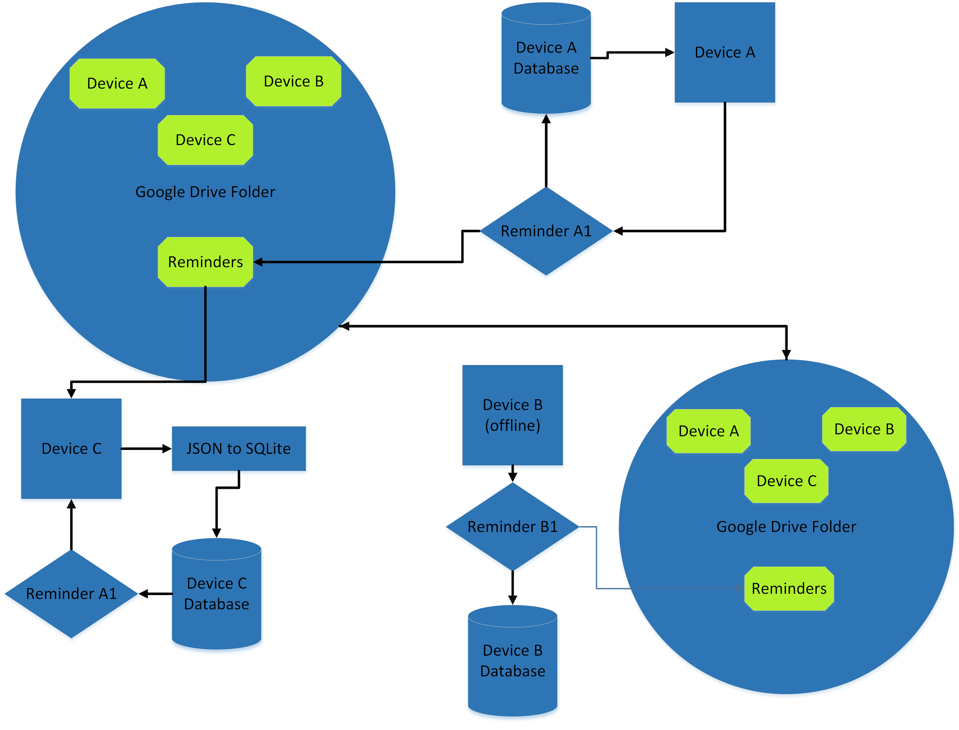

Figure 5

-When Reminders are deleted, the device that proceeded with the deletion will delete the reminder from its SQLite Database and from the Application Data Folder, and send tells to the other devices folder telling them to delete the reminders from the local databases. They are told individually to the deletion tells from adding up, any device that is keeping up with deletions more frequently shouldn’t be hindered into performing more operations because another device is connected less frequently. When a device receives and performs a delete, the tell that it received from its Application Data Folder is deleted after the operations have been completed. In the figure, Device B is offline and doing nothing, Device A is deleting Reminder A1 and Device C is syncing with the deletion initiated by Device A.

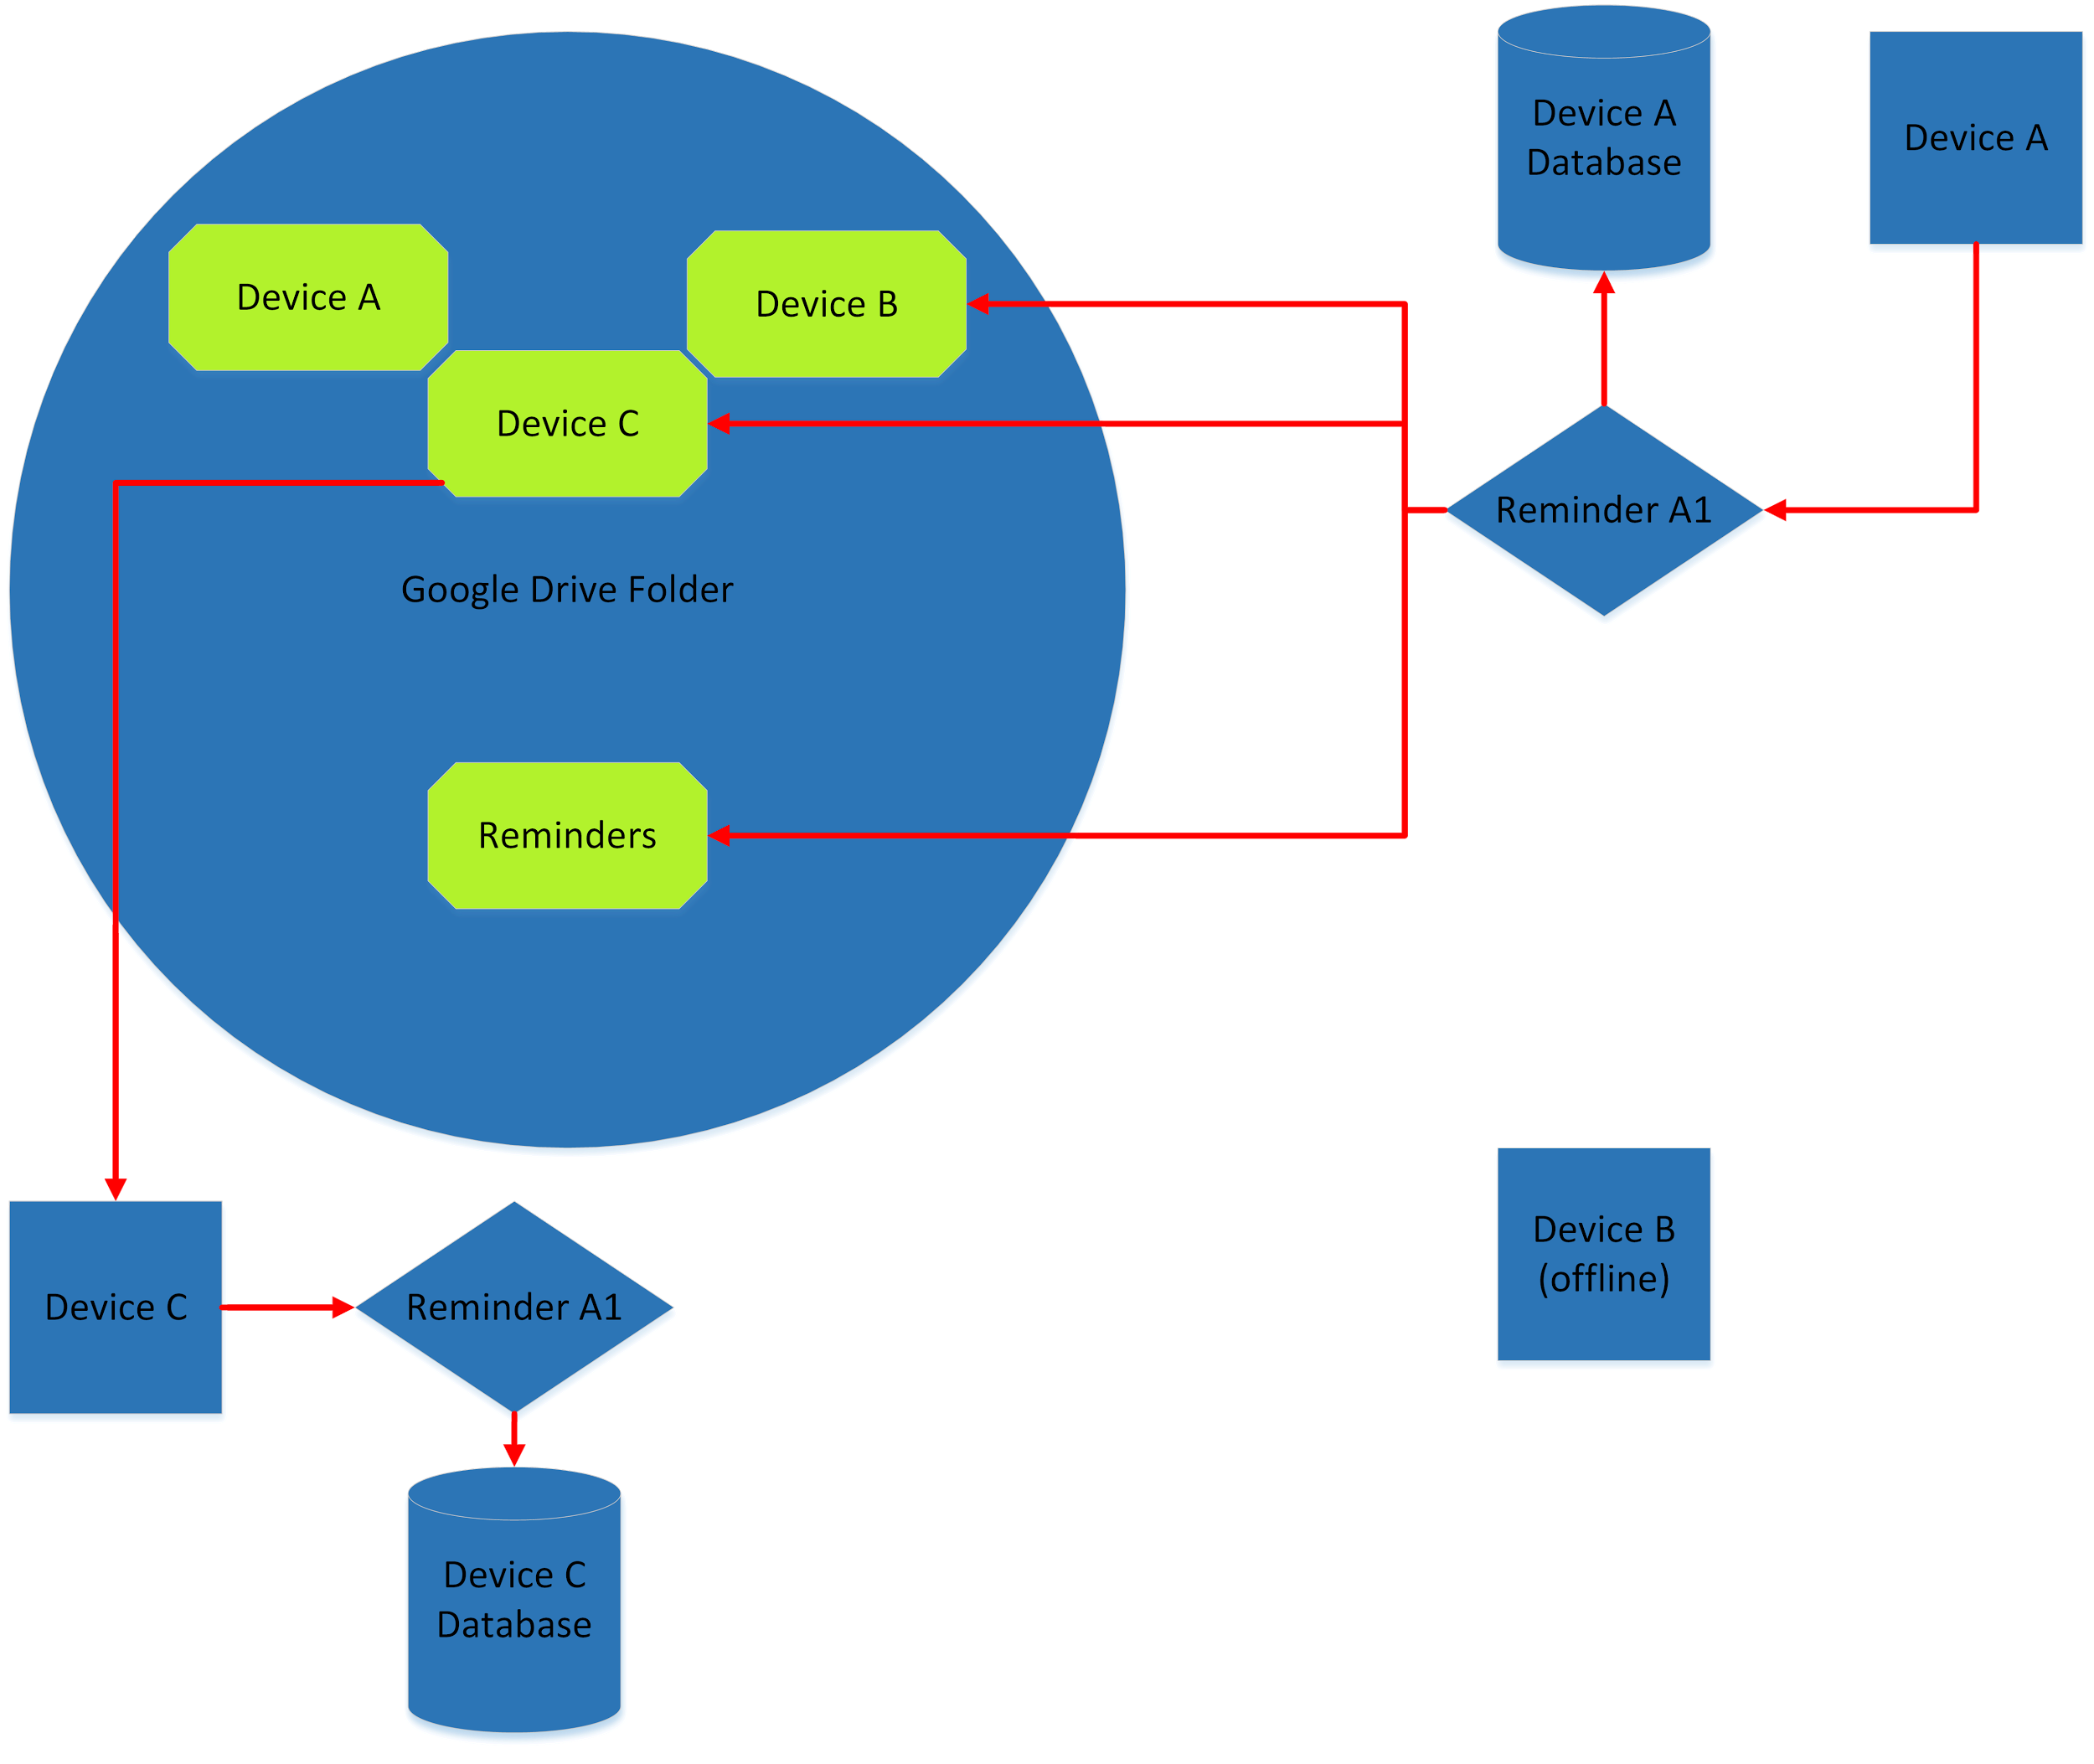

Fig. 6.

Amended Models (New)

Our models have not changed since Progress Report 3.

Designs and Controls (New)

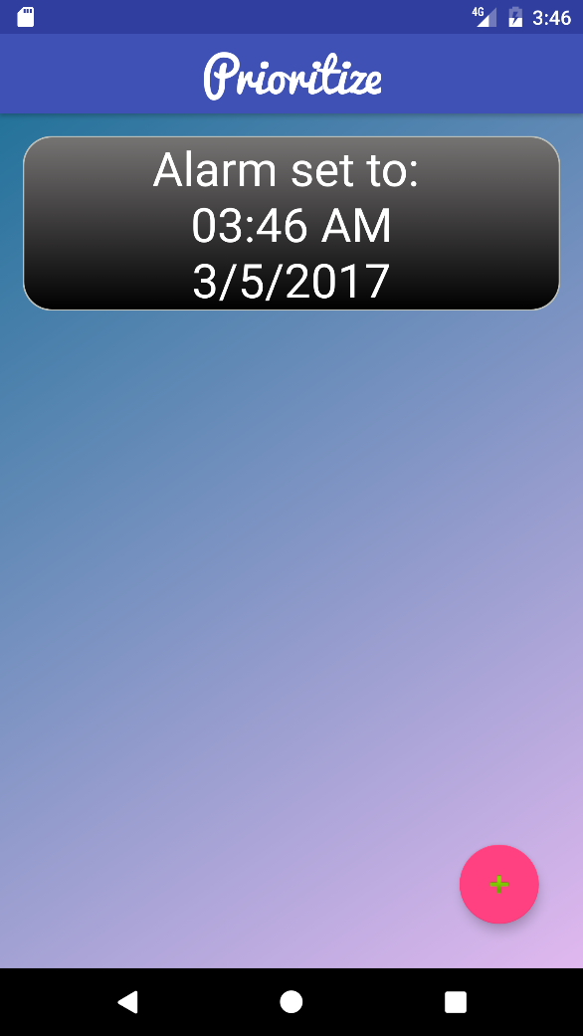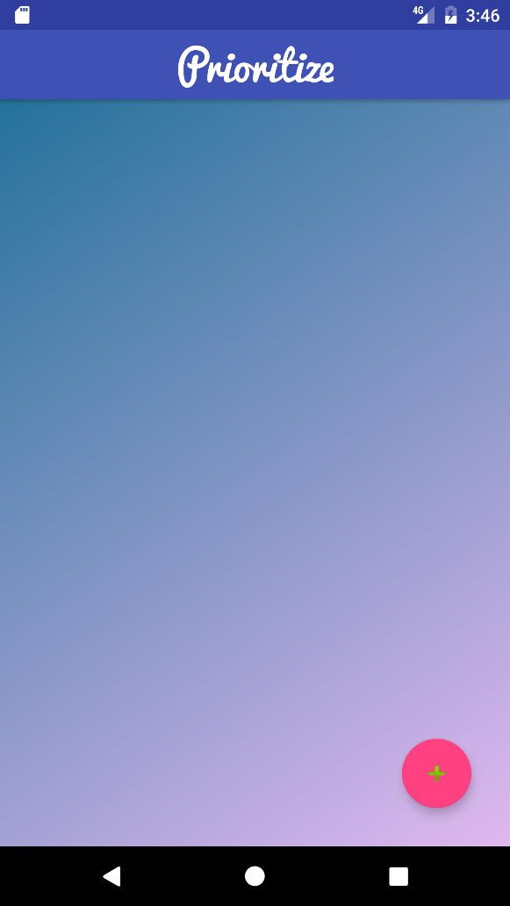.

Fig. 7.

Fig. 8.

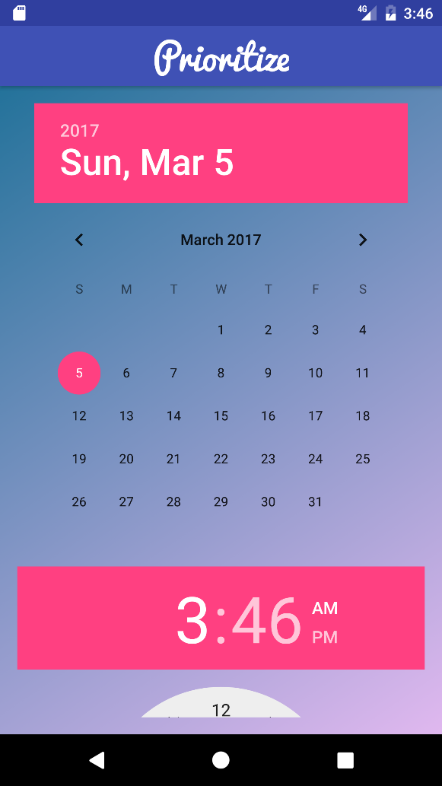Figure 7 and 8 represent the homescreen for the Prioritize Application. In Figure 7, there are no set alarms or alerts that the user needs to be reminded of, or has set. Whereas, in Figure 8, the user has one Alarm set. However, this picture is not a good representation of the final appearance, as there will be design changes to improve the looks and information given in the individual notifications.

Also shown in Figures 7 and 8 is the add reminder button. This button will allow the user to enter a new reminder, which will then be stored locally and within the Google Drive, as shown in above models.

Figure 9 shows the date and time picker for each notification. It will allow the user to select a day and time that the reminder should be due, or if they want to specify when to be reminded, this will let them do that as well.

The other buttons on the bottom screen are standard for any Android device, and are nothing new or special within this application.

Fig. 9.

Citations

[1]"Drive | Google developers," in *Google Drive APIs*, Google Developers. [Online]. Available: https://developers.google.com/drive/. Accessed: Feb. 2017.

[2]"Introducing JSON," in *JSON.org*. [Online]. Available: http://www.json.org/. Accessed: Feb. 20, 2017.

[3]"Android studio the official IDE for Android," in *Android Studio*. [Online]. Available: https://developer.android.com/studio/index.html. Accessed: Feb. 25, 2017.